Student Name | Hayden Druve | Student Number |  | 475452335
Unit Code/s & Name/s | BSBXCS303 Securely manage personally identifiable information and workplace information
Cluster Name  If applicable | N\A
Assessment Name | Portfolio | Assessment Task No. |  | 2 of 2
Assessment Due Date | Week 8
Assessor Name | Adam Garbutt
Student Declaration: I declare that this assessment is my own work. Any ideas and comments made by other people have been acknowledged as references. I understand that if this statement is found to be false, it will be regarded as misconduct and will be subject to disciplinary action as outlined in the TAFE Queensland Student Rules. I understand that by emailing or submitting this assessment electronically, I agree to this Declaration in lieu of a written signature.
Student Signature | Hayden Druve |  | Date | 19/10/2024

Instructions to Student | General Instructions:  You are required to complete Parts 1 – 8 below (starting Page 3 of this document). There will be a variety of practical tasks that require screenshots, explanations, completing templates, checklists and filling out tables. This is an individual assessment. All answers must be in your own words and screenshots must have your name and student number shown within the screenshot. Example: Have a text document open with your name and student number to verify it is your work.  Materials to be supplied by Student:  Access to a computer with:  - Internet access  - Web browser  - Microsoft office  - VirtualBox Virtual Machine Software  - Windows 10 Virtual Machines  - HashCalc, 7zip and/or Eraser Software  Work, Health and Safety:  A work health and safety check of the assessment environment is to be conducted prior to the assessment and any hazards addressed appropriately.  Assessment Criteria:  To achieve a satisfactory result, your assessor will be looking for your ability to demonstrate the following key skills/tasks/knowledge to an acceptable industry standard:  - Classify and label sensitive data according to Anytown Marketing policies  - Encrypt device hard drives  - Implement access controls to sensitive information  - Confirm data integrity by comparing hash values before and after transfer  - Backup sensitive data on-site and off-site  - Complete a Privacy Impact Statement  - Complete a Data Protection Compliance Checklist for GDPR  Number of Attempts:  You will receive up to two (2) attempts at this assessment task. Should your 1st attempt be unsatisfactory (U), your teacher will provide feedback and discuss the relevant sections / questions with you and will arrange a due date for the submission of your 2nd attempt. If your 2nd submission is unsatisfactory (U), or you fail to submit a 2nd attempt, you will receive an overall unsatisfactory result for this assessment task. Only one re-assessment attempt may be granted for each assessment task.  For more information, refer to the Student Rules.
Submission details | Insert your details on page 1 and sign the Student Declaration. Include this form with your submission.  Due Date: Week 8  Submission Details: You are required to complete the tasks in this document in the space provided under each and save the document as BSBXCS303_AT2_<Your Name>  You are also required to complete the following documents and submit them with your completed Portfolio.  ICT30120_BSBXCS303_LHO_PrivacyImpactStatement_Template  ICT30120_BSBXCS303_LHO_DataProtectionChecklist  Once completed, upload the document to the Assessment Task 1 within the BSBXCS303 Unit on Connect. TAFE Queensland Learning Management System: Connect URL: https://connect.tafeqld.edu.au/d2l/login  Username; 9-digit student number  For Password: Reset password go to: https://passwordreset.tafeqld.edu.au/default.aspx
Instructions to Assessor | Specifications of assessment: There are 8 parts including 1 template and 1 checklist as listed below, that must all be completed correctly to achieve a satisfactory result for this assessment.  Equipment or material requirements:  Documents:  - ICT30120_BSBXCS303_LHO_AnytownMarketingPolicies  - ICT30120_BSBXCS303_LHO_StaffInformation  - ICT30120_BSBXCS303_LHO_PrivacyImpactAssessment_Template  - ICT30120_BSBXCS303_LHO_DataProtectionChecklist  - ICT30120_BSBXCS303_LHO_StoredFileDescription  - Access to a computer with:  - Internet access  - Web browser  - Microsoft office  - Virtual Machine Software  - Windows 10 Virtual Machines  - HashCalc Software  Details of location: TAFE will provide a simulated work environment in the classroom; however, it is possible to complete these tasks at home using a computer with internet access and the correct software.  Time restrictions: This is a Portfolio assessment designed to take place over 12 weeks.  Level of assistance permitted: Teachers and/or Tutors should be available in class, and accessible by email for students working from home. Staff cannot directly provide students answers but can guide them to complete tasks individually.  Work Health and Safety: A work health and safety check of the assessment environment is to be conducted prior to the assessment and any hazards addressed appropriately.  Interactions with team members: This is an individual assessment and all assessment submissions should be completed individually. Though some consultation is allowed between the cohort.  Contingencies if conditions cannot be met: Students will be able to resubmit their work a second time after feedback has been provided if they are not successful on the first attempt. Reasonable adjustments will also be made for students as and when appropriate, after consultation with the Accessibility and Counselling team. – You must see your teacher prior to assessment regarding this.
Note to Student | An overview of all Assessment Tasks relevant to this unit is located in the Unit Study Guide.

Scenario: You are employed by Anytown Marketing as an IT consultant to assist in implementing their data security and privacy handling policies and procedures.
See “ICT30120_BSBXCS303_LHO_AnytownMarketingPolicies”. This implementation project is to be completed with the required documentation submitted to the authorising manager.
Note, it’s required to set up a Virtual Machine for this section, we recommend using VirtualBox with the “Win10 Pro VM (OVA)” Provided in Connect.  All visual evidence (screenshots) must include your student details such as Student Name and Student Number (ID). To achieve this, you can use a screenshot tool (for Windows, WIN + SHIFT + S) and overlay text, or simply have a text file open as you take the screenshot.  For example: | 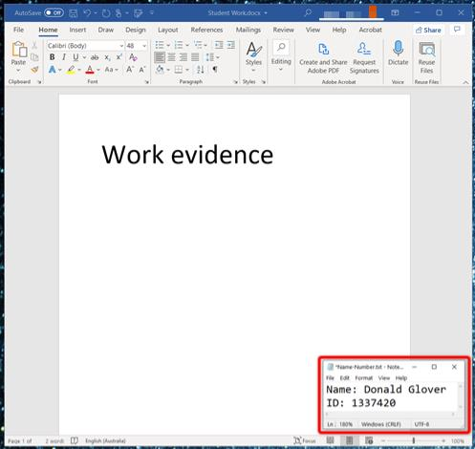
Part 1
You are required to classify ALL (12) the Anytown Marketing Firms’ files into their data classification types and new storage locations. Use the “ICT30120_BSBXCS303_LHO_StoredFileDescription” documents for the file names, types, and description of data within.
Note, Label Colours do not need to be completed practically, meaning, students do not need to provide visual evidence (screenshots). Label Colours must be included in the table below.

Unofficial Files | Location (Website/File Server/ Secure File Server) | Label Colour (None/Yellow/Red)
1. PrivacyPolicy | File Server/Website | None
2. CopyrightPolicy | File server/Website | None
Official Files | Location (Website/File Server/ Secure File Server) | Label Colour (None/Yellow/Red)
1. MediaReleases | Website | Yellow
2. PreviousProjects | File Server | Yellow
3. CurrentProjects | File Server | Yellow
4. StaffHandbook | File Server | Yellow
5. StaffFireTrainingReport | File Server | Yellow
Official: Sensitive Files | Location (Website/File Server/ Secure File Server) | Label Colour (None/Yellow/Red)
1. CurrentClients | Secure File Server | Red
2. PreviousClients | Secure File Server | Red
3. StaffInformation | Secure File Server | Red
4. EmailBackup | Secure File Server | Red
5. UpcomingProjects | Secure file Server | Red
Well done
Part 2
You are required to provide a short explanation (~50 words) on how encryption protects sensitive data.
You then must also demonstrate encrypting data and provide screenshots as evidence. You can do this in two methods:
- add a Virtual Hard Drive to your Virtual Machine and encrypt it using Bitlocker or,
- encrypt a single folder with files using a third-party encryption tool such as 7Zip.
WARNING! Do not encrypt your personal computer’s Hard Drive, you must use a Virtual Machine.
Explanation | Encryption protects sensitive data by scrambling it and making it unreadable without a decryption key. Encryption scrambles data through the use of mathematical algorithms. Encrypted data is theoretically unreadable without the decryption key, with modern encryption methods taking weeks or months for a supercomputer to decrypt. It is a technique that has been around for ages, the Ceaser cipher can be considered a form of encryption.  Well done
Screenshot(s) | 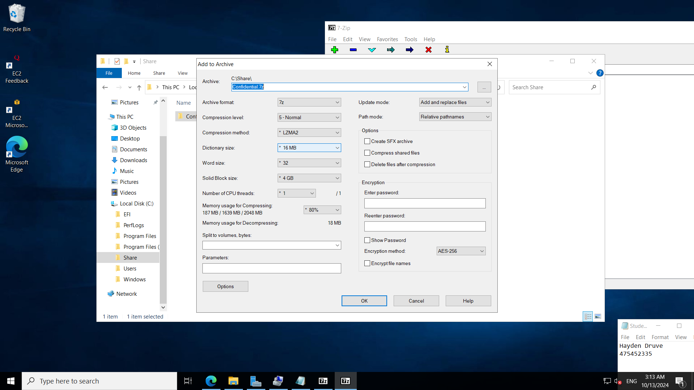  Take a screenshot with the password set (encrypt file names optional)

Part 3
You are required to give a brief explanation (~50 words) for the best practices for sharing sensitive data within the workplace.
You then must demonstrate the following and provide screenshots as evidence of completion:
- Setup a User Group within the Windows 10 Workstation via your Virtual Machine for the Marketing Department. If this feature is not built into your edition of Windows, see Local User and Group Management.
- Label the folder according to the Anytown Marketing policies document and share the folder so only they have access to the folder and the sensitive data within.
- Once the folder has been shared, encrypt the folder and all files within.
Explanation | Some good practice policies for sharing sensitive information include making sure that the people it is being shared with only have as much access and permissions as they need. In addition, you shouldn’t send sensitive information over email or other unsecured methods.  Provide 5 best practices to secure a network share. Describe each best practice in a sentence. Consider technical controls such as the ones you implement in this assessment, and consider procedures people should follow.
Screenshot(s) | Instructions have been clarified in new version of assessment:  Requirements:  - Setup a User Group called MarketingManagers  - Create 5 user accounts as follows:  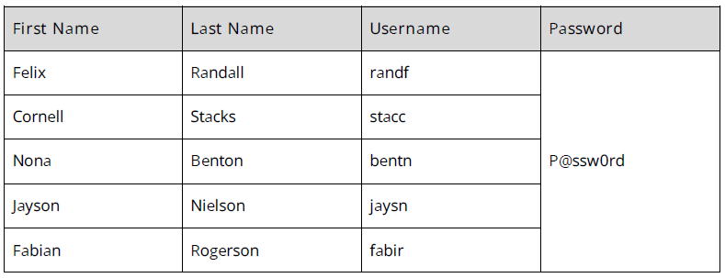  - Add the first two accounts (Felix Randall and Stacks Cornell) to the MarketingManager group.  - Create the folder structure described in AnyTown Marketing Policies. Create 1 or more files for each folder following your classification in Q1.  - Configure the Shared folder as a network share and provide Staff, read access to the Shared folder over the network.  - Configure Security permissions on the Confidential folder and provide modify access to the MarketingManagers group.  - Once the folder has been shared, encrypt the folder and all files within.  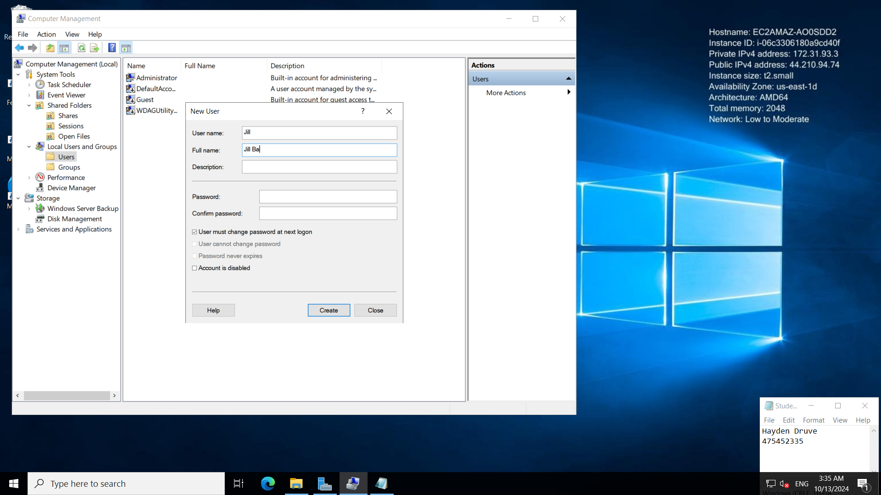  Create 5 user accounts as directed. Follow the naming convention.    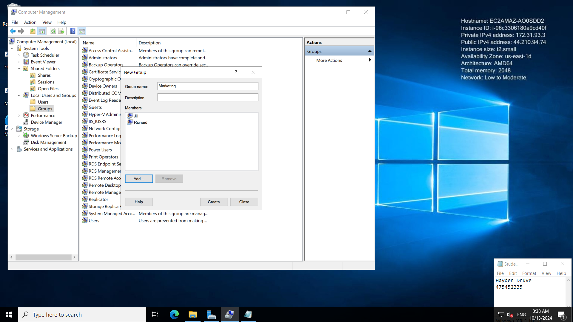  This should be MarketingManagers  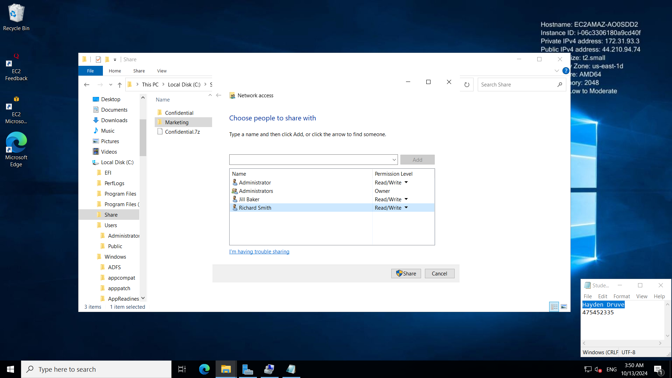  Always assign permissions to a group, not individually.  Assign share permissions to Users group – read/write  Missing: NTFS permissions (control access over network and on local server) – assign modify permissions to the marketingmanagers on the confidential folder.  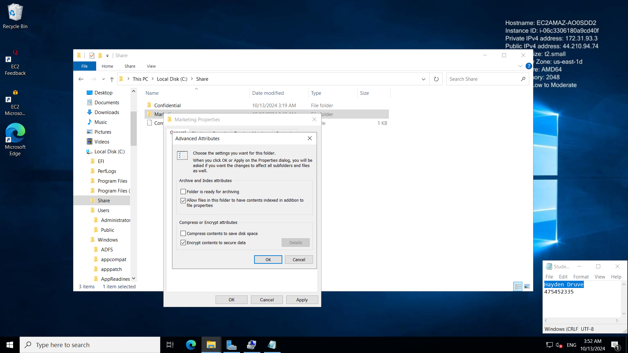  OK for encryption although only the administrator will have access – look at encryption handout to see how to add managers as individual accounts (because certificates required)  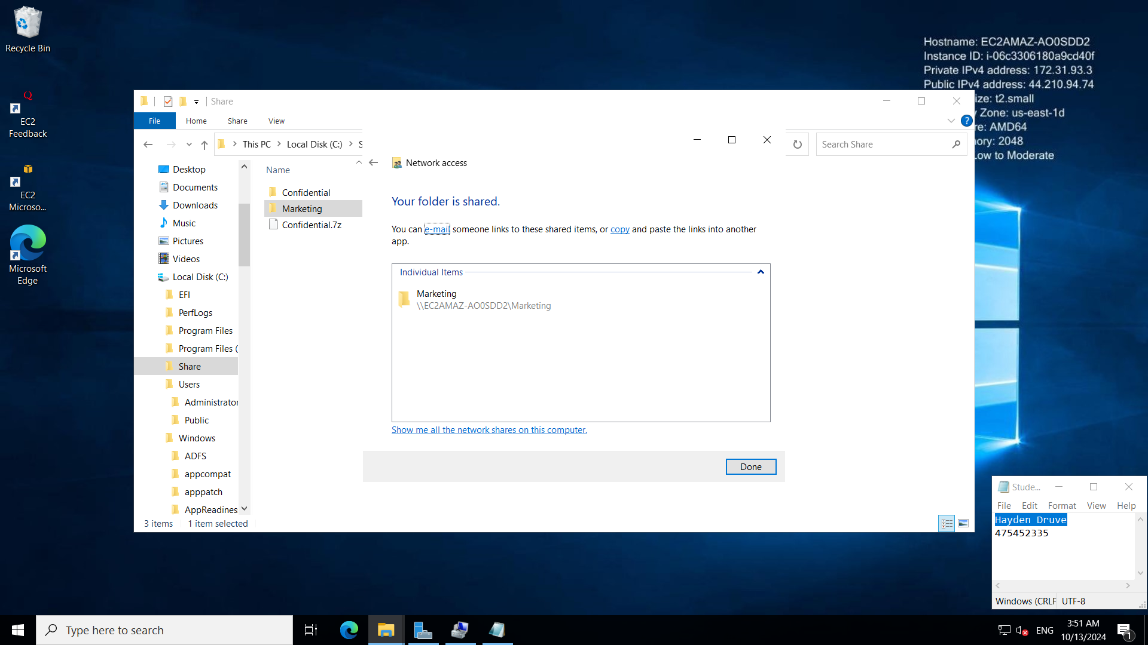  Sharing is Good  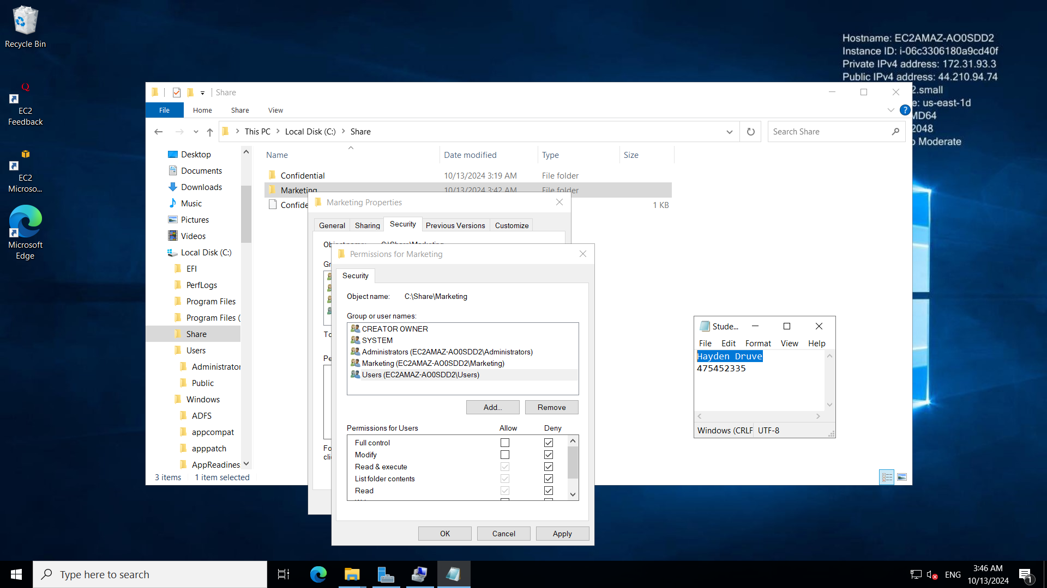  Don’t do it this way because all users belong to users group and a deny overrides an allow permission. Remove the users group instead.  Set up folder structure.  Add permissions to confidential folder.

Part 4
You must perform a hash calculation on the “ICT30120_BSBXCS303_LHO_StaffInformation” document using a hashing algorithm, for example SHA512. Then transfer the file into the encrypted shared folder you created in Part 3 and run the hash calculation again to ensure data integrity after the transfer.
In your Windows 10 Virtual Machine, use one of the two following methods:
- a third-party tool such as 7Zip and HashCalc or,
- a terminal emulator such as PowerShell.
Ensure to include visual evidence of the files hash before the transfer, and after the transfer is complete, multiple screenshots will be required.
Screenshot(s) | 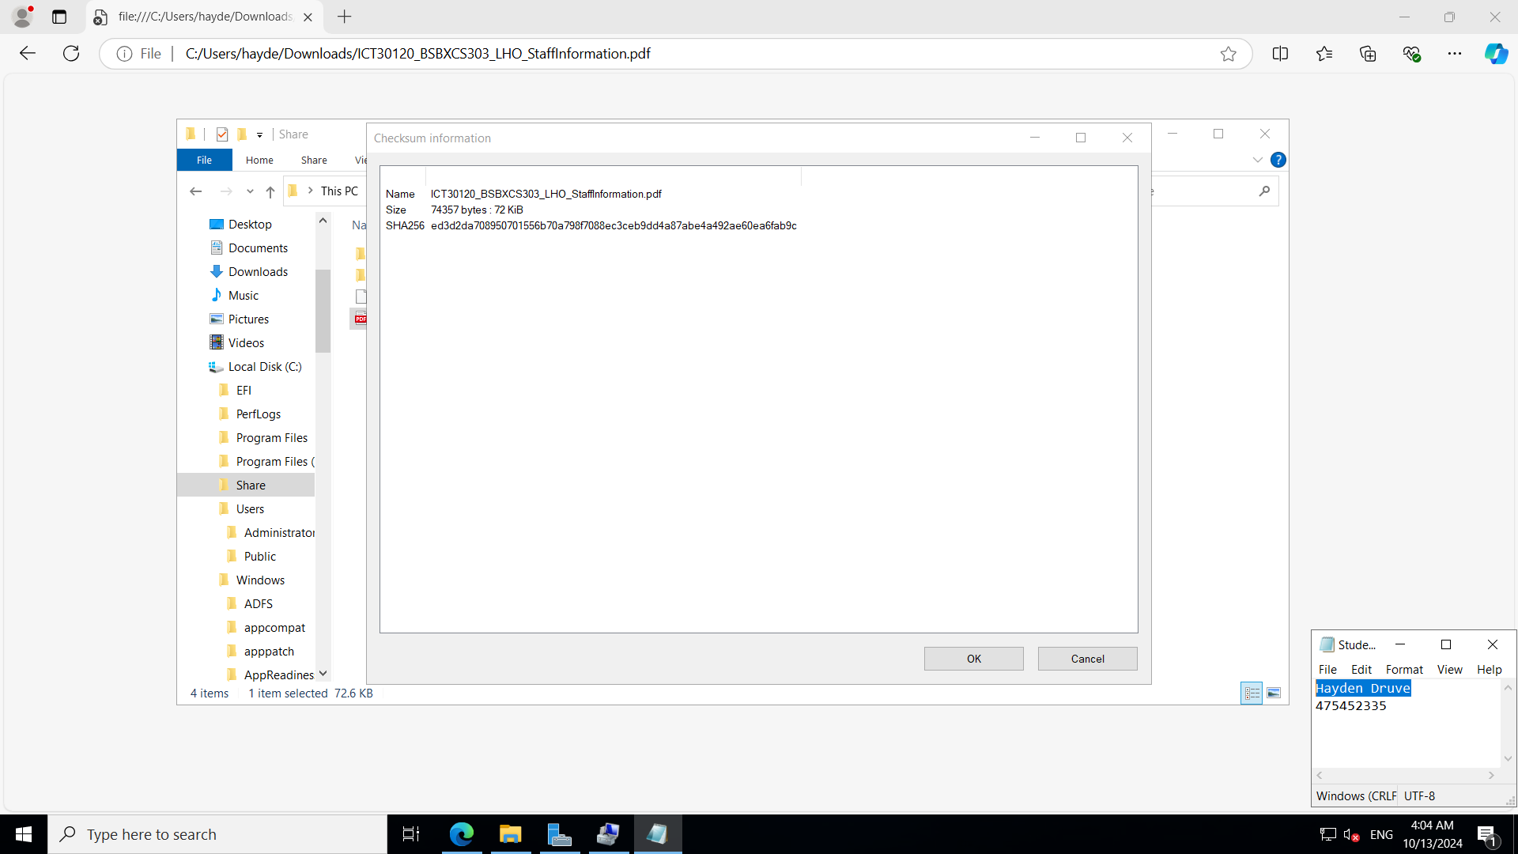  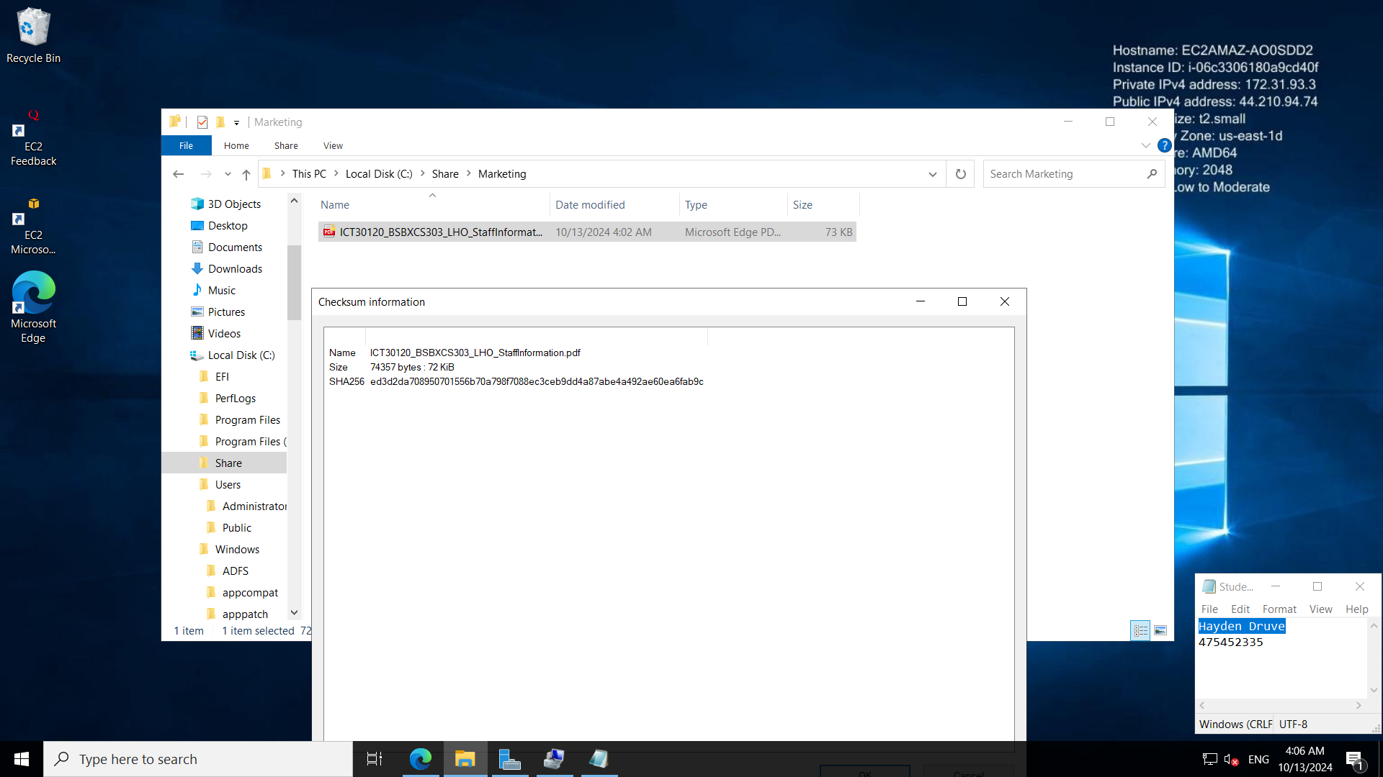  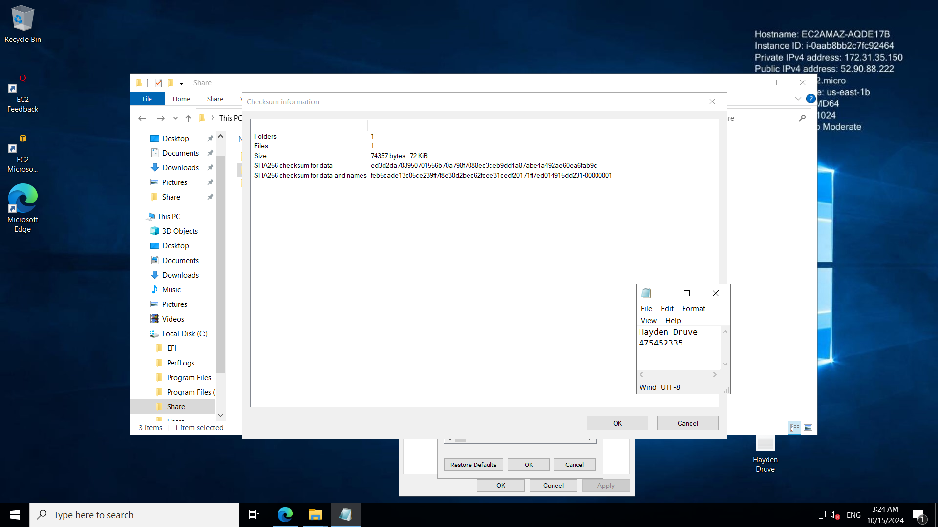  Before and after hashes match  Requirement is for SHA512

Part 5
You are required to explain an attack that would compromise the integrity of sensitive data.
You then must demonstrate setting up file change audits via your Windows 10 Virtual Machine. This is to keep track of changes made to the sensitive data file used in Part 4 to report if attacks have occurred. Provide screenshots as evidence of completion:
Explanation | A social engineering attack is where a hacker attempts to gain access to a system through social engineer. One of the most well-known types of social engineering attack is phishing. Phishing is where someone attempts to gain access through an email, either by pretending to be someone the victim trusts, or by attaching malware to the email. Some good ways to prevent these sorts of attacks is by making sure that your employees are trained to recognise such attacks.  Good answer but not to this question.  Explain what data integrity is?  Explain how hashes provide that a file has integrity.  Describe an attack that attempts to make unauthorised changes to files – it often uses the techniques you describe above to do this, what happens when a file has unauthorised changes?
Screenshot(s) | 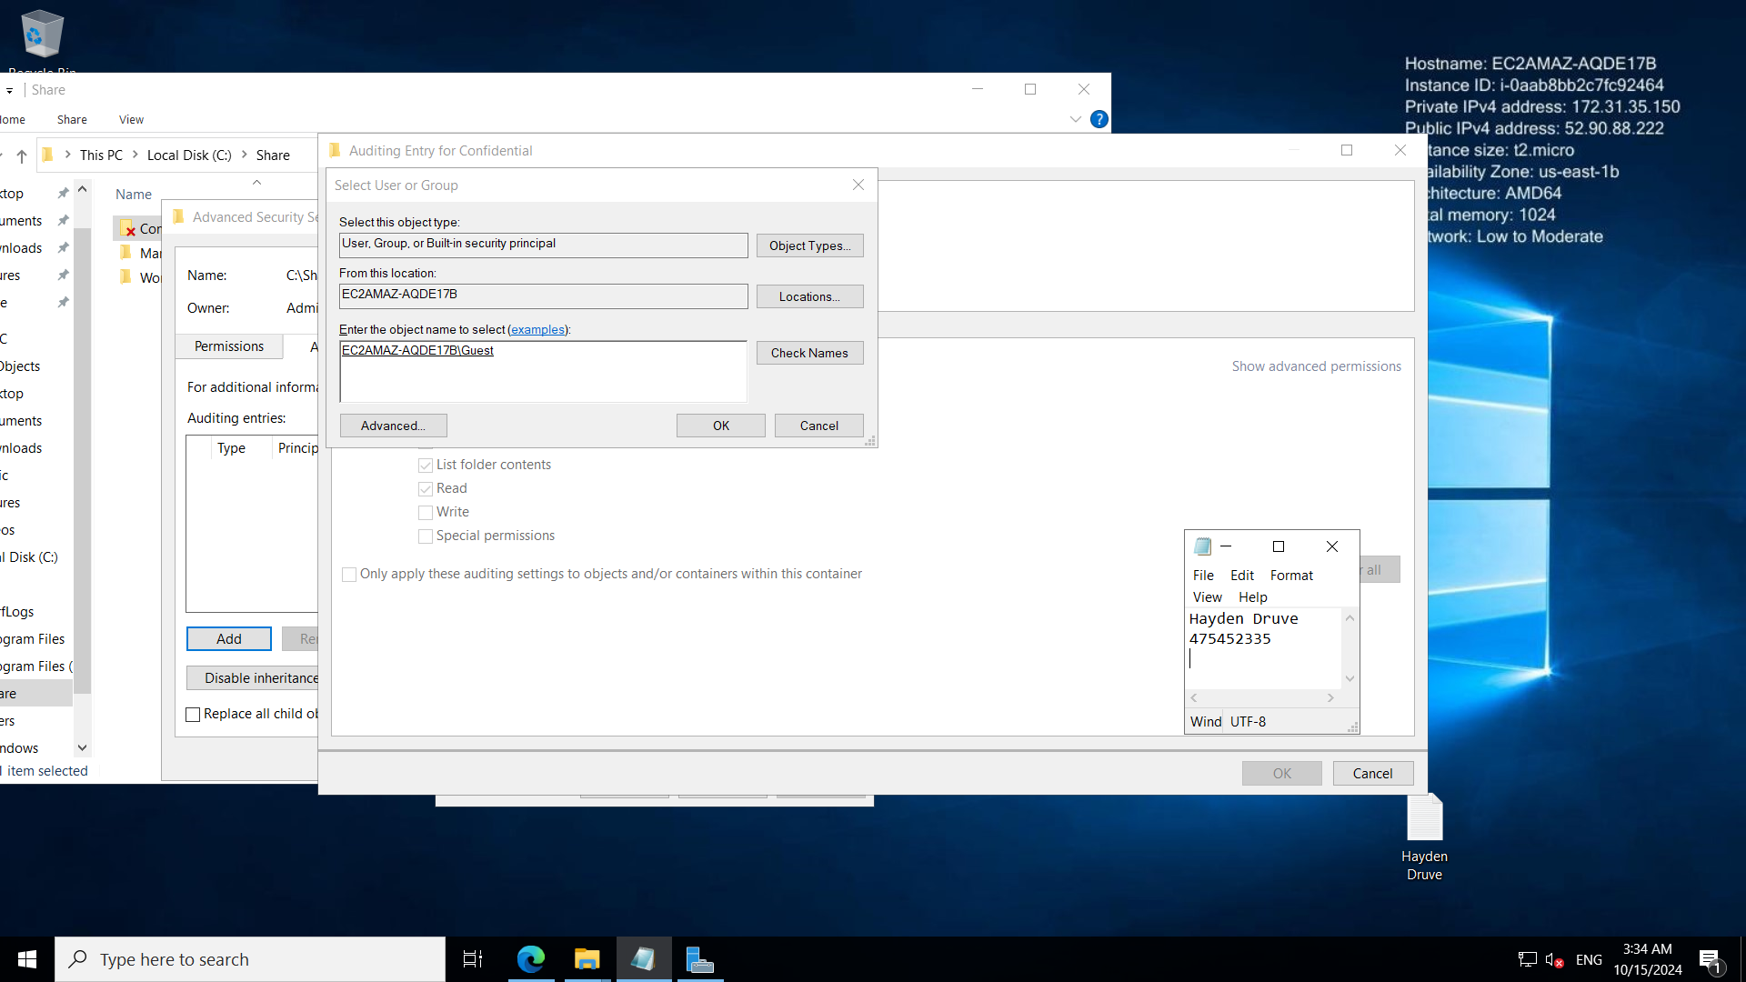  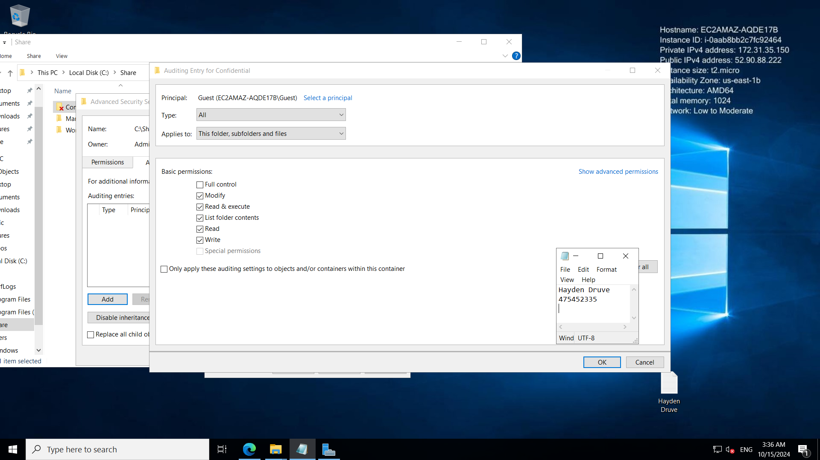 Screenshots required:  - Screenshot of the local security policy for object access showing success and failure ticked.  - Screenshot of properties, advanced, auditing on the folder that is getting audited.  - Screenshot of log in event viewer showing the user accessing the folder (4663 ID or 5145)

Part 6
You are required to explain how you can keep the data integrity intact and secure during transport and at the off-site location.
You then must demonstrate and provide screenshots for backing up the encrypted folder created in Part 3 according to organisational procedures “ICT30120_BSBXCS303_LHO_AnytownMarketingPolicies”. This is required to be backed up to removable storage for transport and storage off-site.
In your Windows 10 Virtual Machine, add a Virtual Hard Drive, then use one of the two following methods to backup data:
- Backup and Restore (Windows 7) or,
- a third-party tool such as FreeFileSync.
Explanation | All backups that exceed 10 gigabytes must not be performed during peak hours. All off site electric storage must be over the cloud through secure connection. Alternatively, it can be in an encrypted USB or hard drive transported by a secure company. All on site electronic storage must be on an encrypted server.  Expecting 5 best practices which you have provided.
Screenshot(s) | 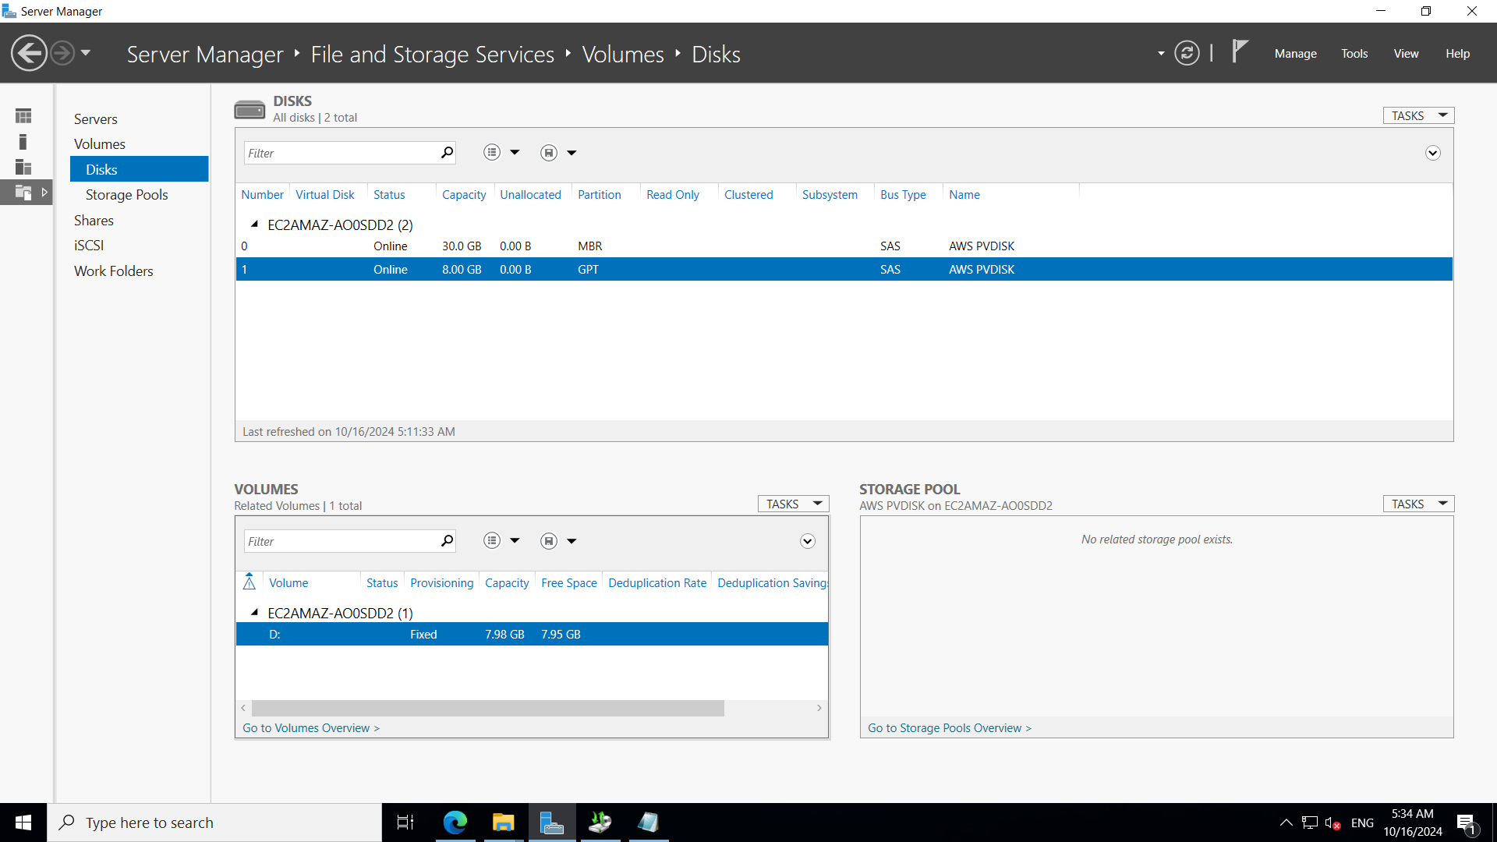  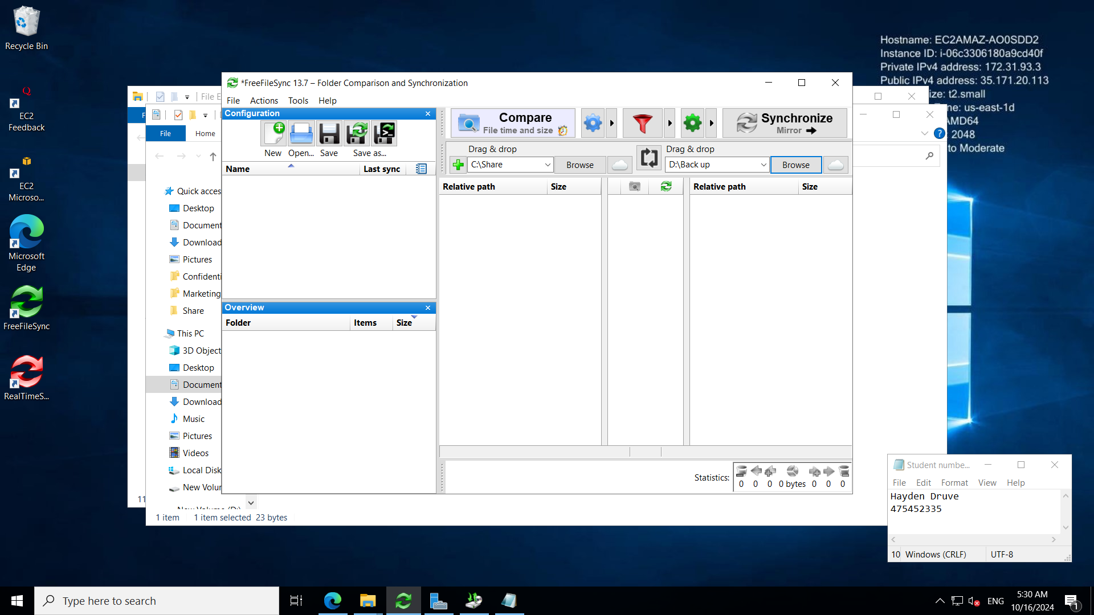  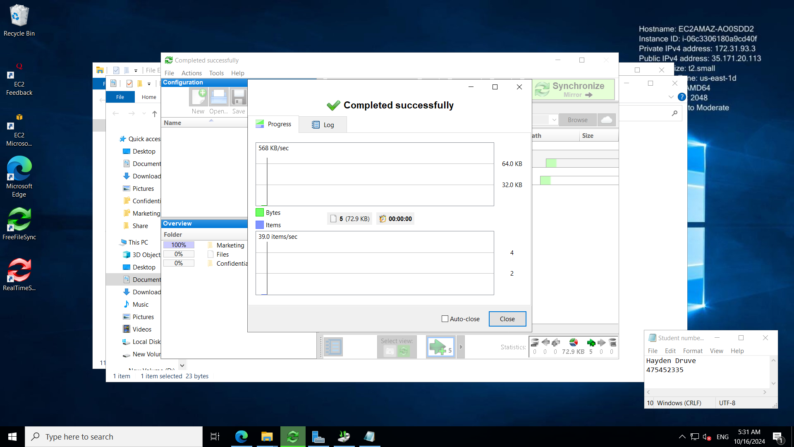  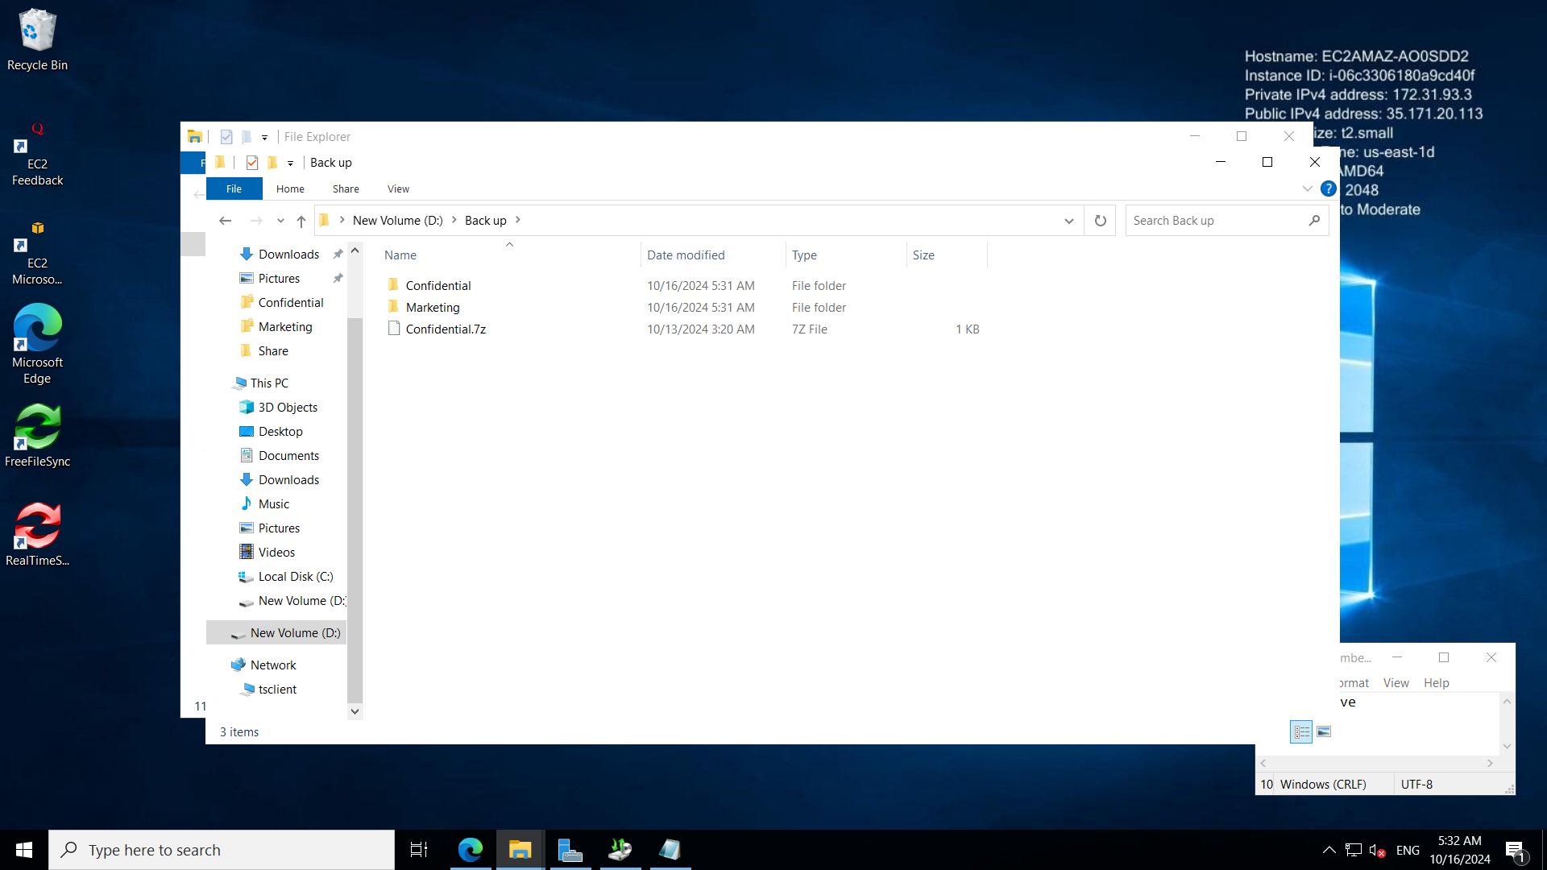  Good screenshots

Part 7
You are required to complete a Privacy Impact Assessment “ICT30120_BSBXCS303_LHO_PrivacyImpactAssessment_Template”. See the PIA template to be completed and submitted with this document.

Part 8
You are required to complete the Data Protection & Compliance Checklist to ensure GDPR compliance “ICT30120_BSBXCS303_LHO_DataProtectionChecklist”. The checklist is to be submitted with this document.

*** END OF ASSESSMENT TASK ***

